Business Requirement Document – Ver 1.0

Global Education E-Commerce Platform

Submitted to:

Revision History
Date | Version | Section Changed | Change Description | Author

DOCUMENT INFORMATION
Document Name : Global Education E-Commerce Platform – Business Requirement Document (BRD)
VERSION : 1.0
PRODUCT : Global Education E-Commerce Platform (Unified System including E-Commerce, Recruitment, Admission, Content & Social Modules)
DATE : 07-Apr-2026
AUTHOR : Business Analyst Team

Document Description
This document provides a comprehensive overview of the business requirements for the Global Education E-Commerce Platform, a unified digital ecosystem that integrates multiple modules including:
- E-Commerce Marketplace for education-related products
- Recruitment Platform for teaching and non-teaching staff
- Admission Management System for educational institutions
- Content & Social Platform for educational content sharing and engagement
- Additional features such as Role-Based Access, Bus Sharing between institutes, and Large-Scale User Onboarding
The document defines the business objectives, scope, functional requirements, workflows, and system expectations required to design and implement a scalable and centralized platform serving students, parents, teachers, vendors, and educational institutions globally.

Modules Covered in this Document
- E-Commerce Module
  - Vendor onboarding
  - Product listing & management
  - User purchase flow
  - Order management & bulk procurement
- Recruitment Module
  - Institute registration
  - Job posting (Teaching/Non-Teaching)
  - Candidate application & tracking
  - Interview scheduling
- Admission Module
  - Admission notifications
  - Student/parent application process
  - Pre-admission functionality
  - Alternative institute suggestions
- Content & Social Platform Module
  - Video/content publishing
  - Social engagement (like, comment, follow – “Shisya”)
  - Messaging/chat system
- Additional Platform Features
  - Role-based access control
  - Bus sharing between institutes
  - High-scale onboarding (50L+ students, 5L+ institutes)

Table of Content
1. DOCUMENT INFORMATION 3
1.1. Document Description 3
1.2. Modules Covered in this Document 3
2. Table of Content 4
3. PURPOSE OF THE DOCUMENT : 6
4. Business Objective: 6
5. Scope : 7
5.1. In Scope: 7
5.1.1. E-Commerce Module 7
5.1.2. Recruitment Module 7
5.1.3. Admission Module 8
5.1.4. Content & Social Platform Module 8
5.1.5. Additional Platform Features 8
5.2. Out of Scope: 8
6. Stakeholders : 9
6.1. Business Stakeholders 9
6.2. Primary Users (End Users) 9
6.3. Operational Stakeholders 10
6.4. Technical Stakeholders 10
6.5. Supporting Stakeholders 10
7. Proposed System : 10
7.1. Unified Platform Architecture 11
7.2. E-Commerce Module 11
7.3. Recruitment Module 11
7.4. Admission Module 11
7.5. Content & Social Platform Module 12
7.6. Additional Platform Features 12
7.7. System Capabilities & Characteristics 12
8. Business Requirements : 12
8.1. E-Commerce Module 13
8.2. Recruitment Module 15
8.3. Admission Module 16
8.4. Content & Social Platform Module 17
8.5. Additional Platform Features 19
9. Flow Chart 20
10. Assumptions : 21
11. Constraints : 22
12. Dependencies : 23
12.1. Technical Dependencies 23
12.2. Business & Operational Dependencies 23
12.3. User Dependencies 23
12.4. Third-Party Dependencies 24
12.5. Administrative Dependencies 24
13. Sign Off 24

PURPOSE OF THE DOCUMENT :
The purpose of this Business Requirement Document (BRD) is to define the comprehensive business requirements for implementing the Global Education E-Commerce Platform, a unified digital ecosystem that integrates E-Commerce, Recruitment, Admission, Content & Social interaction, and additional institutional collaboration features into a single platform.
This document aims to provide a clear and structured understanding of how various stakeholders such as vendors, students, parents, teachers, and educational institutions will interact with the system to perform activities such as buying and selling educational products, applying for jobs, managing admissions, publishing and consuming educational content, and collaborating with other institutions.
The BRD outlines the functional scope, workflows, and system expectations required to build a scalable, role-based, and user-centric platform capable of supporting large-scale onboarding of users and institutions. It also serves as a reference for aligning business objectives with technical implementation, ensuring transparency, efficiency, and standardization across all modules.
Additionally, this document establishes a foundation for system design, development, testing, and deployment by capturing all key business processes, including vendor management, job recruitment, admission lifecycle management, content engagement, communication features, and resource-sharing mechanisms such as inter-institutional bus allocation.

Business Objective:
- To establish a unified digital ecosystem that integrates E-Commerce, Recruitment, Admission, and Content & Social functionalities into a single platform, enabling seamless interaction between students, parents, teachers, vendors, and educational institutions.
- To create a centralized marketplace for education-related products, allowing vendors to efficiently onboard, manage inventory, and sell products such as books, uniforms, electronics, and institutional equipment, while providing users with a convenient and transparent purchasing experience.
- To streamline and standardize the education recruitment process by enabling institutions to post job vacancies, manage applications, shortlist candidates, and schedule interviews, while allowing teachers and job seekers to discover and apply for relevant opportunities in a structured manner.
- To simplify and digitize the admission lifecycle by providing a centralized platform where institutions can publish admission notifications and students/parents can search, compare, and apply to multiple institutes, including support for pre-admission applications and automated submission workflows.
- To enhance student success and reduce application drop-offs by introducing intelligent recommendation mechanisms, which suggest alternative institutions based on user profile, preferences, and eligibility when applications are rejected.
- To build a knowledge-sharing ecosystem through a content platform where teachers and institutions can publish educational videos and posts, enabling continuous learning and engagement similar to modern digital platforms.
- To foster community-driven learning and interaction by enabling users to follow content creators (Shisya concept), engage through likes, comments, and shares, and communicate via real-time messaging features.
- To enable efficient resource utilization and collaboration among institutions, such as facilitating bus sharing requests between nearby institutes, thereby optimizing operational resources and reducing costs.
- To implement a robust role-based access control system, ensuring that different user types (Vendor, Student, Teacher, Parent, Institute, Admin) have access to relevant features and dashboards tailored to their responsibilities.
- To design a highly scalable and performance-driven platform capable of onboarding and supporting millions of users (50+ lakh students and 5+ lakh institutions), ensuring reliability, availability, and seamless user experience under high traffic conditions.
- To ensure transparency, traceability, and accountability across all modules by maintaining activity logs, application statuses, order tracking, and audit trails for all user actions.
- To provide a secure and compliant system environment, ensuring safe handling of user data, secure transactions, and adherence to data protection standards.
- To enable future scalability and extensibility, allowing the platform to incorporate advanced features such as AI-based recommendations, analytics, online interviews, and integrations with external systems in subsequent phases.

Scope :

In Scope:
Development of a unified Global Education Platform integrating multiple modules including E-Commerce, Recruitment, Admission, Content & Social, and institutional collaboration features.

E-Commerce Module
Vendor registration, onboarding, and profile management
Product listing, categorization (Books, Stationery, Uniforms, Electronics, Furniture, etc.), and inventory management
Product search, filtering, and detailed product view
Shopping cart, checkout, and order placement functionality
Integration with payment gateway (UPI, Cards, Net Banking)
Order management including order tracking and status updates
Vendor order fulfillment and shipping updates
Bulk purchase functionality for institutions
Product reviews and ratings by users

Recruitment Module
- Institute registration and profile management for recruitment
- Job posting creation for teaching and non-teaching roles
- Job categorization and structured job descriptions
- Job search and filtering functionality for candidates
- Resume upload and job application submission
- Application tracking and status updates
- Candidate shortlisting by institutes
- Interview scheduling (offline process)
- Notification system for job and application updates

Admission Module
- Admission notification creation and publishing by institutes
- Admission search and filtering by students/parents
- Admission application submission (internal/external link support)
- Pre-admission application functionality (before admission opens)
- Automated submission of pre-admission applications when admissions open
- Application tracking and status updates
- Institute-side application review and management
- Alternative institute suggestion mechanism for rejected applications
- Segregation of pre-admission and active applications

Content & Social Platform Module
- Educational video upload and publishing by teachers/institutes
- Content metadata management (title, description, tags)
- Content browsing, search, and viewing
- User engagement features (like, comment, share)
- Follow/unfollow functionality (Shisya concept)
- Social content posting (text/image-based posts)
- Newsfeed for content visibility
- Real-time chat and messaging between users
- Notification system for engagement and communication

Additional Platform Features
- Role-based access control for all user types (Vendor, Student, Parent, Teacher, Institute, Admin)
- Role-specific dashboards and feature accessibility
- Bus sharing feature enabling institutes to request and provide transportation resources
- Notification system across all modules (Email/SMS/In-App)
- Large-scale onboarding capability supporting 50+ lakh students and 5+ lakh institutions
- Scalable system architecture ensuring high availability and performance
- Secure data storage and user data protection mechanisms
- Audit trail and activity tracking across modules

Out of Scope:
- AI-based recommendation engine for products, jobs, or admissions (Phase 1 exclusion)
- Online interview/video conferencing integration
- Online entrance examination and evaluation systems
- Admission fee payment integration (Phase 1)
- Integration with external ERP systems of institutions or vendors
- Advanced analytics, dashboards, and reporting tools
- Live streaming functionality in content platform
- Automated content moderation using AI
- Third-party social media integrations (Facebook, Instagram, etc.)
- Fully automated logistics and delivery management systems
- Monetization features such as subscriptions, ads, or commissions (future phase)

Stakeholders :
The following stakeholders are involved in or impacted by the Global Education E-Commerce Platform. They are categorized based on their roles and level of interaction with the system.

Business Stakeholders
- Managing Director (MD)
Responsible for defining the overall vision, strategic direction, and final decision-making authority for the platform.
- Product Owner / Business Head
Responsible for translating business vision into product features, prioritizing requirements, and ensuring alignment with business goals.

Primary Users (End Users)
- Students
Use the platform to search for educational products, apply for admissions, consume content, and engage with teachers and institutions.
- Parents/Guardians
Act on behalf of students to purchase products, apply for admissions, and track application or order progress.
- Teachers (Job Seekers & Content Creators)
Apply for jobs, publish educational content, interact with followers (Shisya’s), and communicate with other users.
- Educational Institutions (Schools/Colleges/Universities)
Register on the platform to post job vacancies, manage admissions, publish content, and participate in resource sharing (e.g., bus sharing).
- Vendors (Sellers)
Register to sell education-related products, manage inventory, process orders, and fulfill deliveries.

Operational Stakeholders
- Admin Team
Responsible for platform monitoring, user approvals (vendors/institutes), content moderation, and overall system governance.
- Institute Admission Teams
Manage admission applications, review candidates, and update application status within the system.
- Institute HR / Recruitment Teams
Handle job postings, review applications, shortlist candidates, and coordinate interview processes.
- Logistics/Delivery Partners
Support the delivery of products purchased through the platform (if integrated or vendor-managed).

Technical Stakeholders
- Development Team
Responsible for designing, developing, and implementing system functionalities across all modules.
- QA (Quality Assurance) Team
Responsible for testing the system to ensure functionality, performance, and quality standards are met.
- System Administrator
Manages system configurations, user roles, permissions, and overall system health.
- IT Infrastructure/Cloud Team
Ensures system scalability, availability, performance, and data security for large-scale onboarding.

Supporting Stakeholders
- Customer Support Team
Handles user queries, complaints, and issue resolution across all modules.
- Finance/Accounts Team
Manages financial transactions, payment reconciliations, and vendor settlements (E-Commerce module).
- Marketing Team
Promotes platform adoption, user engagement, and onboarding of institutions, vendors, and users.

Proposed System :
The proposed system is a comprehensive Global Education E-Commerce Platform that integrates multiple core modules—E-Commerce, Recruitment, Admission, Content & Social Platform, and additional institutional collaboration features—into a single, unified, and scalable digital ecosystem.
This platform is designed to serve as a one-stop solution for the education sector, enabling seamless interaction between students, parents, teachers, vendors, and educational institutions while standardizing and digitizing key processes.

Unified Platform Architecture
The system will provide a centralized platform where all users can access multiple services using a single login with role-based access control.
Each user (Vendor, Student, Parent, Teacher, Institute, Admin) will be provided with a customized dashboard displaying relevant functionalities and workflows based on their role.
The platform will be designed with a modular architecture, allowing independent operation of each module while ensuring seamless integration across all functionalities.

E-Commerce Module
- Vendors will be able to register, create profiles, and onboard onto the platform after admin approval.
- Vendors can upload and manage products related to the education ecosystem, including books, uniforms, electronics, and institutional equipment.
- Users (students, parents, teachers, institutions) can search, filter, and purchase products through a structured and user-friendly interface.
- The system will support cart management, secure payment processing, order tracking, and vendor-side order fulfillment workflows.
- Institutions will have the capability to perform bulk purchases and optionally request quotations for large orders.

Recruitment Module
- Educational institutions will be able to register and manage recruitment activities within the platform.
- Institutes can create and publish job postings for teaching and non-teaching roles with detailed job descriptions.
- Teachers and job seekers can search, filter, and apply for jobs, upload resumes, and track application status.
- Institutes can review applications, shortlist candidates, and schedule interviews, with interview execution occurring offline.
- The system will maintain a centralized candidate database for future recruitment needs.

Admission Module
- Institutes can publish structured admission notifications including eligibility criteria, course details, intake capacity, and important dates.
- Students and parents can search, compare, and apply to multiple institutes through a centralized platform.
- The system will support both internal application forms and external admission links.
- A unique Pre-Admission feature will allow users to apply even before admissions open, with the system automatically submitting applications when admissions become active.
- The system will provide real-time application tracking and enable institutes to manage and update application statuses.
- In case of rejection, the system will provide intelligent suggestions for alternative institutes based on user profile and preferences.

Content & Social Platform Module
- Teachers and institutions can upload and publish educational videos and posts, creating a knowledge-sharing ecosystem similar to modern content platforms.
- Users can browse, search, and consume content, and engage through likes, comments, and shares.
- Users can follow content creators (Shisya concept) to receive updates and build a personalized learning feed.
- The platform will provide a social media-like experience, including a newsfeed and interactive content visibility.
- A real-time chat/messaging system will enable communication between users, fostering collaboration and learning communities.

Additional Platform Features
- A robust Role-Based Access Control (RBAC) system will ensure that each user can only access features relevant to their role.
- The platform will include a Bus Sharing feature, enabling institutes to request and provide transportation resources to nearby institutions for specific days, improving operational efficiency.
- A centralized notification system will inform users about activities such as orders, applications, job updates, content engagement, and messages.
- The platform will be designed for large-scale onboarding, supporting more than 50 lakh students and 5 lakh institutions.
- The system will leverage scalable cloud infrastructure to ensure high availability, performance, and reliability under heavy traffic conditions.
- All user activities and transactions will be recorded to maintain a complete audit trail, transparency, and accountability.

System Capabilities & Characteristics
- Scalability: Ability to handle millions of users and transactions simultaneously.
- Security: Secure authentication, data protection, and safe transaction handling.
- Performance: Optimized response time for high user traffic.
- Usability: Intuitive and user-friendly interface across web and mobile platforms.
- Extensibility: Designed to support future enhancements such as AI recommendations, analytics, and integrations.

Business Requirements :

ID | Requirement Description
BR-01 | System shall provide a unified platform named "Global Education E-Commerce Platform".
BR-02 | System shall support role-based user registration (Vendor, Student, Parent, Teacher, Institute, Admin).
BR-03 | System shall implement secure login and authentication mechanisms.
BR-04 | System shall provide role-based dashboards with restricted access.

E-Commerce Module
ID | Requirement Description
BR-05 | Vendors shall be able to register and create profiles.
BR-06 | System shall validate vendor details via email/mobile verification.
BR-07 | Admin shall approve or reject vendor registrations.
BR-08 | Vendors shall be able to upload and manage products.
BR-09 | System shall provide predefined product categories.
BR-10 | Vendors shall enter product details (name, description, price, stock).
BR-11 | Vendors shall upload product images.
BR-12 | Users shall be able to search products using keywords.
BR-13 | System shall provide product filtering options (price, category, rating).
BR-14 | Users shall be able to view product details.
BR-15 | Users shall be able to add products to cart.
BR-16 | Users shall be able to modify cart (update/remove items).
BR-17 | System shall provide checkout functionality.
BR-18 | System shall integrate with payment gateway.
BR-19 | System shall generate order confirmation.
BR-20 | Vendors shall receive order notifications.
BR-21 | Vendors shall process and fulfill orders.
BR-22 | Vendors shall update order status (Processing/Shipped/Delivered).
BR-23 | Users shall track order status.
BR-24 | System shall support bulk orders for institutions.
BR-25 | System shall allow product reviews and ratings.
BR-26 | System shall maintain order history.
BR-27 | System shall support vendor inventory management.

Recruitment Module
ID | Requirement Description
BR-28 | Institutes shall be able to register for recruitment.
BR-29 | Admin shall approve or reject institute registrations.
BR-30 | Institutes shall manage their profiles.
BR-31 | Institutes shall create and publish job postings.
BR-32 | System shall classify jobs (Teaching / Non-Teaching).
BR-33 | Institutes shall enter job details (role, subject, experience, salary).
BR-34 | Candidates shall search jobs using keywords.
BR-35 | System shall provide job filtering options.
BR-36 | Candidates shall view job details.
BR-37 | Candidates shall upload resumes.
BR-38 | Candidates shall apply for jobs.
BR-39 | System shall store job applications.
BR-40 | Institutes shall review applications.
BR-41 | Institutes shall shortlist candidates.
BR-42 | Institutes shall update application status.
BR-43 | System shall notify candidates of updates.
BR-44 | Institutes shall schedule interviews (offline).
BR-45 | System shall capture interview details.
BR-46 | System shall maintain candidate database.

Admission Module
ID | Requirement Description
BR-47 | Institutes shall publish admission notifications.
BR-48 | Institutes shall define eligibility, courses, intake, and dates.
BR-49 | Institutes shall provide admission links (internal/external).
BR-50 | Users shall search admission opportunities.
BR-51 | System shall provide admission filters (location, course, level).
BR-52 | Users shall view institute admission details.
BR-53 | Users shall apply for admissions.
BR-54 | System shall provide application forms.
BR-55 | Users shall submit personal and academic details.
BR-56 | System shall store applications.
BR-57 | Users shall track application status.
BR-58 | System shall allow pre-admission applications.
BR-59 | System shall store pre-admissions separately.
BR-60 | System shall auto-submit pre-admission applications.
BR-61 | System shall notify users of submission.
BR-62 | Institutes shall review applications.
BR-63 | Institutes shall shortlist/reject applications.
BR-64 | System shall suggest alternative institutes.
BR-65 | Users shall reapply to suggested institutes.

Content & Social Platform Module
ID | Requirement Description
BR-66 | Users shall upload educational videos.
BR-67 | System shall allow metadata entry (title, description, tags).
BR-68 | Users shall publish content.
BR-69 | System shall make content searchable.
BR-70 | Users shall browse and watch content.
BR-71 | Users shall like, comment, and share content.
BR-72 | Users shall follow/unfollow creators (Shisya concept).
BR-73 | System shall maintain follower list.
BR-74 | Teachers shall create social posts.
BR-75 | System shall provide newsfeed.
BR-76 | Users shall interact with posts.
BR-77 | System shall provide chat functionality.
BR-78 | Users shall send and receive messages.
BR-79 | System shall notify engagement activities.

Additional Platform Features
ID | Requirement Description
BR-80 | System shall implement role-based access control.
BR-81 | System shall display role-specific dashboards.
BR-82 | System shall restrict unauthorized access.
BR-83 | Institutes shall raise bus requests.
BR-84 | System shall notify nearby institutes.
BR-85 | Institutes shall respond to requests.
BR-86 | System shall allow selection and approval of bus provider.
BR-87 | System shall record bus allocation details.
BR-88 | System shall support large-scale onboarding.
BR-89 | System shall implement scalable infrastructure.
BR-90 | System shall ensure secure data storage.
BR-91 | System shall maintain audit trail.
BR-92 | System shall support notifications across modules.

Flow Chart
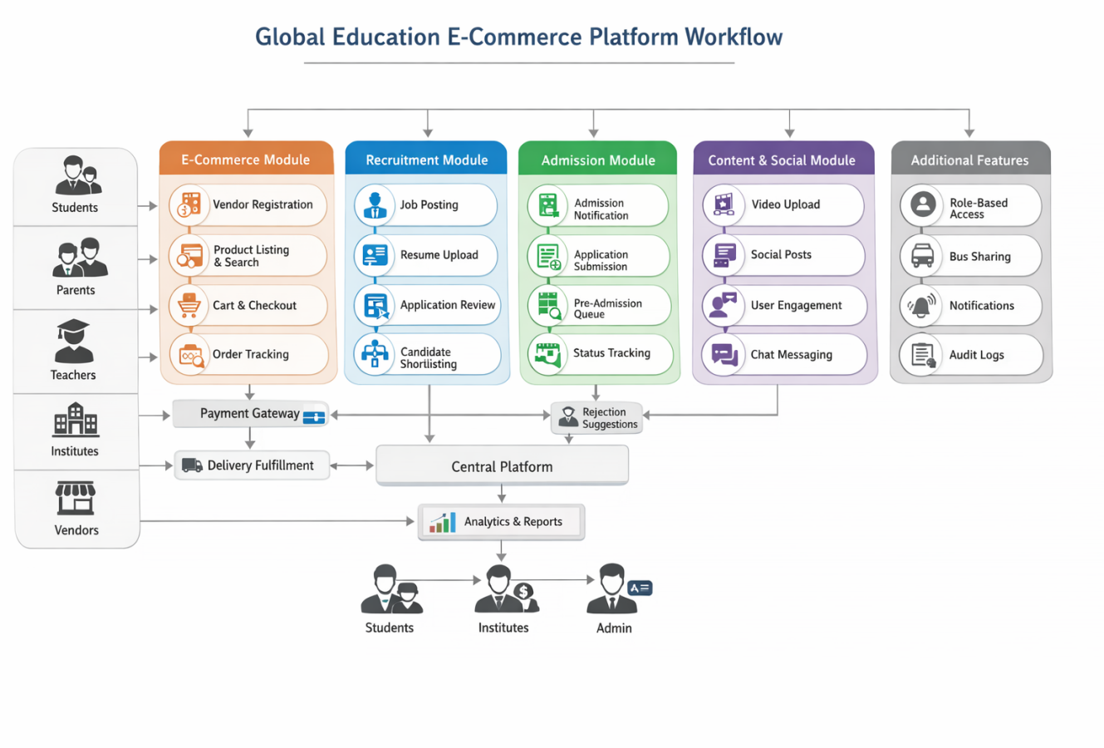
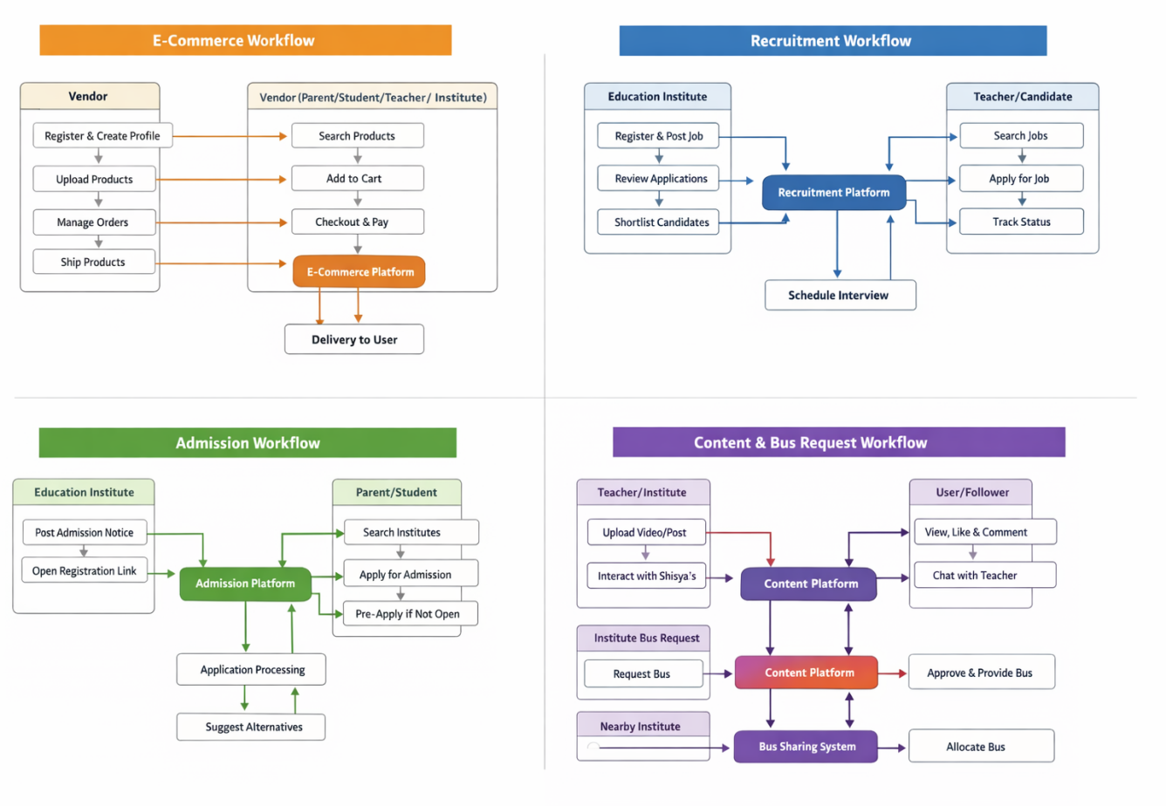

Assumptions :
- All users (Vendors, Students, Parents, Teachers, Institutes, Admins) will have valid and unique login credentials to access the platform.
- Users will provide accurate, complete, and authentic information during registration, product listing, job application, and admission processes.
- Vendors will maintain correct product details, pricing, and inventory levels, and ensure timely order fulfillment.
- Educational institutions will provide accurate admission details, job postings, and institutional information, and will update statuses in a timely manner.
- Teachers and candidates will upload valid resumes, qualifications, and supporting documents while applying for jobs or admissions.
- All payments made through the platform will be processed via secure and reliable third-party payment gateways, and such services will be consistently available.
- Logistics and product delivery will be handled by vendors or external delivery partners, and the platform will not be responsible for physical delivery execution in Phase 1.
- Admission decisions, job shortlisting, and interview processes will be controlled by institutes and may involve offline activities outside the system.
- Pre-admission functionality will rely on accurate mapping of institute, course, and academic year, and system logic will correctly trigger auto-submission when admissions open.
- Users will have stable internet connectivity for accessing the platform, uploading content, submitting applications, and performing transactions.
- Content uploaded by users (videos, posts, comments) will adhere to platform guidelines and acceptable usage policies.
- Real-time chat and messaging features will function within the platform using standard network availability, without guaranteed delivery in case of connectivity issues.
- Institutes participating in bus sharing will cooperate and respond responsibly to requests based on availability and mutual agreement.
- The platform will be deployed on a scalable cloud infrastructure, capable of handling high user traffic and concurrent operations.
- The system will support onboarding of large user volumes (50+ lakh students and 5+ lakh institutions) without significant performance degradation.
- Role-based access control will be properly configured, and users will operate only within their permitted roles and functionalities.
- Notifications (Email/SMS/In-App) will be delivered through integrated third-party services, and minor delays may occur depending on service providers.
- The platform will maintain basic audit logs and activity tracking, assuming all system interactions are recorded for monitoring and traceability.

Constraints :
- The platform will operate within a phased implementation approach, and advanced features such as AI recommendations, analytics, and automation will not be included in Phase 1.
- The system will have dependency on third-party services such as payment gateways, email/SMS notification providers, and hosting infrastructure, which may impact availability and performance.
- Payment processing is subject to external gateway reliability, transaction failures, and regulatory constraints, which are outside the control of the platform.
- Logistics and product delivery will not be directly controlled by the platform, as it depends on vendors or external delivery partners, potentially affecting delivery timelines and tracking accuracy.
- Recruitment processes such as shortlisting and interview scheduling are dependent on institute actions, and delays may occur due to manual intervention.
- Interview processes will be conducted offline, and the system will only capture scheduling details without managing execution or feedback workflows.
- Admission processes, including application review and decision-making, are controlled by institutes, which may result in delays or inconsistencies in status updates.
- The pre-admission auto-submission feature depends on accurate admission timelines and system triggers; any incorrect configuration may lead to delayed or failed submissions.
- External admission links may redirect users outside the platform, limiting control over user experience and tracking of application completion.
- The system will support basic content upload and engagement features, but advanced moderation and content filtering will be limited in Phase 1.
- Large media uploads (videos) may impact system performance, storage, and bandwidth utilization, especially under high concurrent usage.
- Real-time features such as chat and notifications may experience delays depending on network conditions and third-party service performance.
- • The platform must support high user volume (50+ lakh students, 5+ lakh institutes), which may introduce performance constraints during peak usage periods.
- System performance and response time may vary based on server load, concurrent users, and infrastructure limitations.
- Role-based access control must be strictly enforced; however, misconfiguration of roles or permissions may lead to access issues.
- Bus sharing functionality depends on manual participation and coordination between institutes, and availability cannot be guaranteed by the system.
- The system will rely on user-provided data, and incorrect or incomplete information may affect outcomes such as product listings, job applications, and admission processing.
- The platform will not initially support deep integrations with external systems (ERP, LMS, university systems), which may limit interoperability in Phase 1.

Dependencies :
The successful implementation and operation of the Global Education E-Commerce Platform depend on the following internal and external factors:

Technical Dependencies
- The platform depends on a robust and scalable cloud infrastructure to support high user volumes (50+ lakh students and 5+ lakh institutions) and ensure system availability and performance.
- The system requires integration with secure payment gateway services to enable seamless and reliable online transactions for the E-Commerce module.
- The platform depends on notification services (Email, SMS, Push Notifications) to communicate updates related to orders, applications, job postings, content engagement, and system alerts.
- The system relies on media storage and content delivery mechanisms (e.g., cloud storage/CDN) for efficient upload, storage, and streaming of videos and images.
- Real-time features such as chat depend on messaging infrastructure and network stability for timely communication between users.
- The platform depends on a secure authentication and role-based access control system for managing user identities and permissions.

Business & Operational Dependencies
- Vendor onboarding and product availability depend on active participation and timely registration of vendors.
- Order fulfillment depends on vendors and logistics/delivery partners for packing, shipping, and delivering products.
- Recruitment workflows depend on institutes actively posting jobs, reviewing applications, and updating statuses.
- Admission processes depend on institutes publishing accurate admission notifications and managing application reviews.
- Pre-admission functionality depends on correct configuration of admission timelines and institute data.
- Content platform success depends on teachers and institutions consistently creating and publishing quality educational content.
- Social engagement features depend on user participation (likes, comments, follows, interactions) to build an active community.
- Bus sharing functionality depends on cooperation and responsiveness of nearby institutes for accepting and fulfilling requests.

User Dependencies
- The system depends on users providing accurate and complete data during registration, applications, and transactions.
- Platform adoption depends on user awareness, onboarding, and engagement across all roles (students, parents, teachers, vendors, institutes).
- Users must have reliable internet connectivity and compatible devices to access platform features effectively.

Third-Party Dependencies
- Payment processing depends on external payment gateway providers, including their uptime, transaction success rate, and compliance requirements.
- Notification delivery depends on third-party email and SMS service providers, which may introduce delays or failures.
- Media handling depends on cloud storage and CDN services for efficient content delivery.
- Hosting and scalability depend on cloud service providers for infrastructure reliability and performance.

Administrative Dependencies
- Admin team is responsible for approving vendors and institutes, which impacts onboarding timelines.
- Admin monitoring is required for content moderation, user management, and system governance.
- System configuration and role management depend on accurate setup by system administrators.

Sign Off
The following members from VAPS Human Resource Management System are part of BRD discussion for requirement gathering. This is to confirm that Requirements mentioned in this document is the final scope.

S No. | Name | Designation/Department | Signature
1
2
3
4
5
6
7
8
9
10
11
12
13
14
15
16
17

